Eugene Baldonado

SID: 862070316

S22 ECON108_32

Lab 3

C. Considering the results from A and B, it can be assumed that E(U|X) is not equal to 0. There are biases per state that are not controlled for, and that can adjust the estimated coefficient away from 0. Assuming that there are less differences per state over time (over the years from 1976 to 1982) the data can be controlled by getting the state’s average from violentrate and uerate to prevent the biases from each state to affect the relationship. For example, there is a higher on average violent rate in the District of Columbia (fips 11), than California (fips 6), which increases the expected error away making the estimated value more than the actual value and biased away from 0.

2. Merged Data:

Collapsed Data:

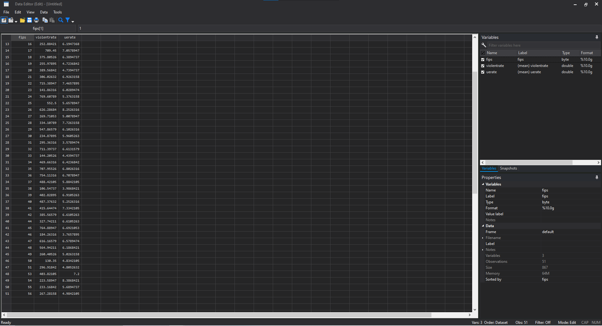

3.

4.

5. In the prior regression and scatter plots, the regression is made on all states observations over the years, and considers all states without any biases to each other, which is why the data is more scattered and the connection between unemployment and violent crime rate is less clear. After collapsing the data to have each state be a single observation (an average made to each state) over the years, the connection between unemployment rate and violent rate is more controlled for these per state biases and the correlation between unemployment rate and violent crime rate is more concrete. To sum up, the collapsed data’s regression is on the average crime rates effects in comparison to the average unemployment rate and in controlling the biases per state, the differences between states (traditionally have more crime rate/unemployment rate) shows the relationship between unemployment rate and violent crime rate.